**1. Create Table Name : Student and Exam**

**Table 1 : Student**

CREATE TABLE STUDENT(

Rollno INT PRIMARY KEY AUTO_INCREMENT NOT NULL,

Name VARCHAR(40),

Branch VARCHAR(50)

);

INSERT INTO STUDENT(Rollno,Name,Branch) VALUES

(1,"Udit","Information Technology"),

(2,"Jay","Computer Science"),

(3,"Kriti","Computer Science");

SELECT * FROM STUDENT;

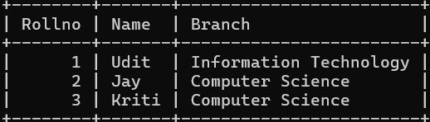

**Table 2 : Exam**

CREATE TABLE Exam(

EnrollmentNo INT, FOREIGN KEY(EnrollmentNo) REFERENCE STUDENT(Rollno),

S_code VARCHAR(10),

Marks INT,

P_code VARCHAR(10)

);

INSERT INTO Exam(EnrollmentNo,S_code,Marks,P_code) VALUES

(1,"IT11",50,"IT"),

(1,"IT12",60,"IT"),

(2,"CS101",66,"CS"),

(2,"CS102",70,"CS"),

(3,"CS101",45,"CS"),

(3,"CS102",50,"CS");

SELECT * FROM STUDENT;

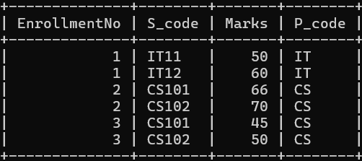

SELECT STUDENT.Rollno, STUDENT.Name, STUDENT.Branch, Exam.S_code, Exam.Marks, Exam.EnrollmentNo FROM STUDENT INNER JOIN Exam ON STUDENT.Rollno=Exam.EnrollmentNo;

